Action=**BOLD**

Object= “parenthesis”

Dialogue Box Title = *Italics*

Subsection = underline

GenAlEx stands for Genetic Analysis in Excel. It is an excel add in for population genetic analysis.

Data Data was generated from the raw data file, 'Microsatellite genotype data.xlsx', which was already in GenAlEx format. All data generated during the analysis is automatically saved as sheets in the excel workbook, and has been saved under 'microsatellite_genotype_genalex.xlsx'.

Analysis The analysis was done by working through the GenAlEx tutorials, published on the GenAlEx website, which are saved in the GenAlEx_tutorials folder.

1. Organize the excel workbook into a readable format for the geneAlEx
2. Plot Allele Frequency
   1. **SELECT** “GenAlEx” from Ribbon
   2. **SELECT** “Frequency Based” button
   3. **SELECT** “Frequency” from GenAlEx drop down menu.
   4. Dialogue *Allele Frequency Data Parameters* 
      1. **SELECT** Codominant under Two Columns/Locus “OK”
   5. A screenshot of a cell phone

      Description automatically generated
   6. Dialogue *Codominant Frequency Options* **SELECT**
      1. “Graph by Pop for Each locus”
      2. A screenshot of a cell phone

         Description automatically generated
   7. **SELECT** “OK”
   8. GenAlEx will spit a bunch of pie graphs and data sheets for us analyze showing the Allele frequency in each population by location.
3. Heterozygosity, F-statistics, and Allelic Patterns
   1. **SELECT** “GenAlEx” from Ribbon
   2. **SELECT** “Frequency Based” button
   3. **SELECT** “Frequency” from GenAlEx drop down menu.
   4. Dialogue *Allele Frequency Data Parameters*
      1. **SELECT “**Codominant” under Two Columns/Locus “OK”
   5. A screenshot of a cell phone

      Description automatically generated
   6. Dialogue *Codominant Frequency Options*
      1. **SELECT** “Frequency by Pop” under Allele Frequency and Heterozygosity.
      2. **SELECT** “Het, Fstat & Poly by Pop” under Allele Frequency and Heterozygosity.
      3. **SELECT** “Het, Fstat & Poly by Locus” under Allele Frequency and Heterozygosity.
      4. **SELECT** “Allelic Patterns” under Allelic Patterns Options
      5. **SELECT** “Graph Pattern” under Allelic Patterns Options
      6. A screenshot of a cell phone

         Description automatically generated
   7. **SELECT** “OK”
   8. More Graphs
4. Shannon Indices
   1. **SELECT** “GenAlEx” from Ribbon
   2. **SELECT** “Frequency Based” button
   3. **SELECT** “Shannon” from GenAlEx drop down menu.
   4. **SELECT** “Pairwise Pops”
   5. Dialogue *Allele Frequency Data Parameters* 
      1. **SELECT “**Codominant” under Two Columns/Locus “OK”
   6. Dialogue *Pairwise Pops Shannon Analysis Options*
      1. 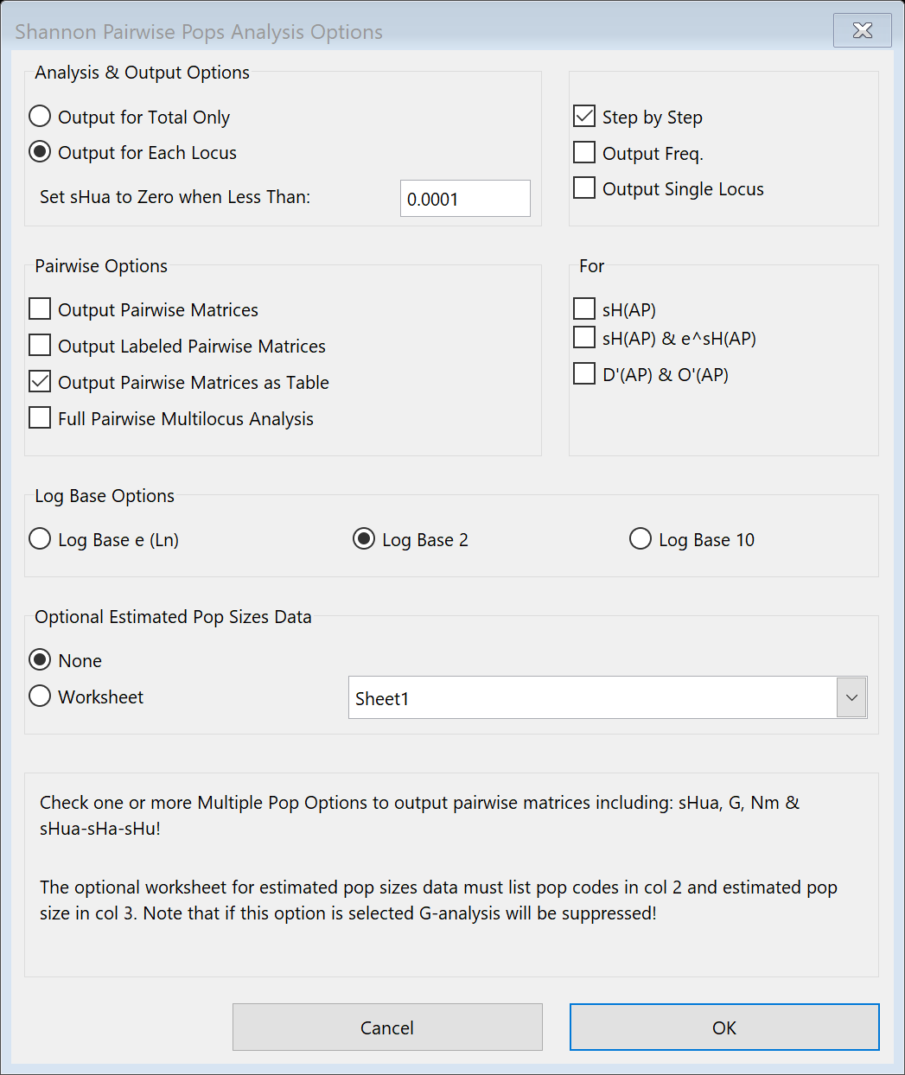
   7. **SELECT** “OK”
5. Nei Distance
   1. **SELECT** “GenAlEx” from Ribbon
   2. **SELECT** “Frequency Based” button
   3. **SELECT** “Frequency” from GenAlEx drop down menu.
   4. Dialogue *Allele Frequency Data Parameters* 
      1. **SELECT** Codominant under Two Columns/Locus “OK”
   5. Dialogue *Codominant Frequency Options*
      1. **SELECT** “Nei Distance” under Multiple Pop Options.
   6. 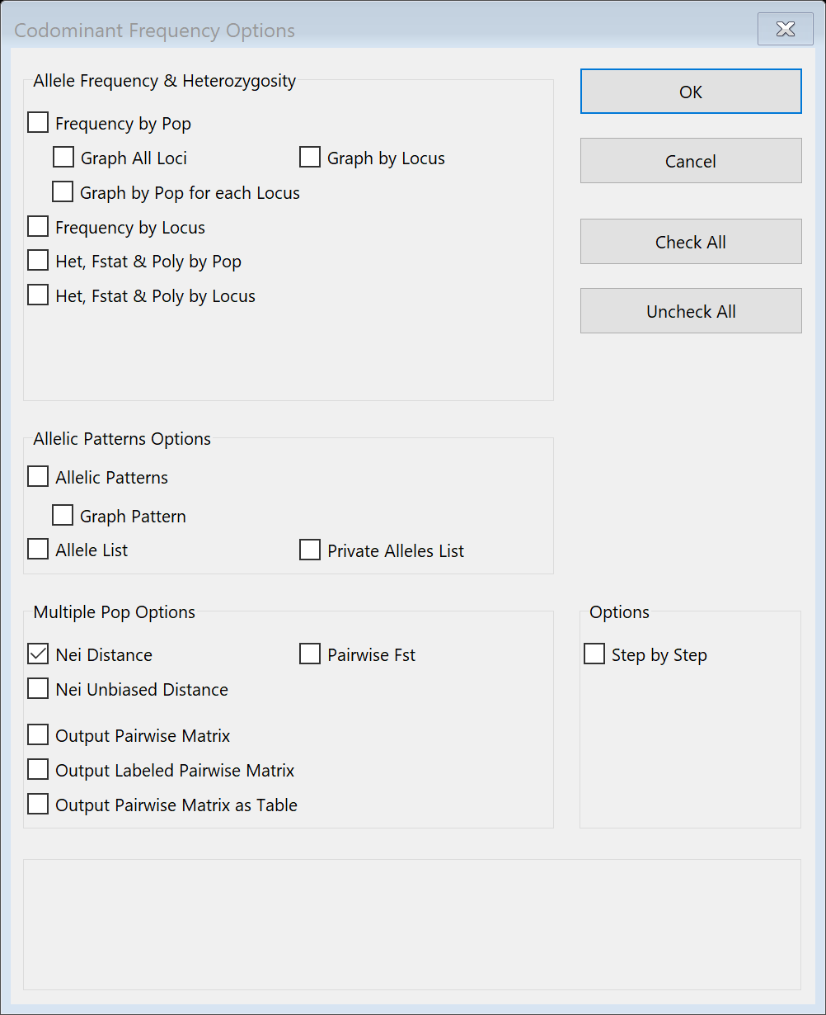
   7. **SELECT** “OK”
6. Pairwise Fst and Nei Genetic Distances
   1. **SELECT** “GenAlEx” from Ribbon
   2. **SELECT** “Frequency Based” button
   3. **SELECT** “Frequency” from GenAlEx drop down menu.
   4. Dialogue *Allele Frequency Data Parameters* 
      1. **SELECT** Codominant under Two Columns/Locus “OK”
   5. Dialogue *Codominant Frequency Options*
      1. **SELECT** “Nei Distance” under Multiple Pop Options.
      2. **SELECT** “Output Pairwise Matrix” under Multiple Pop Options.
      3. **SELECT** “Output Labeled Pairwise Matrix” under Multiple Pop Options
      4. **SELECT** “Output Pairwise Matrix as Table” under Multiple Pop Options
      5. **SELECT** “Pairwise Fst” under Multiple Pop Options
      6. 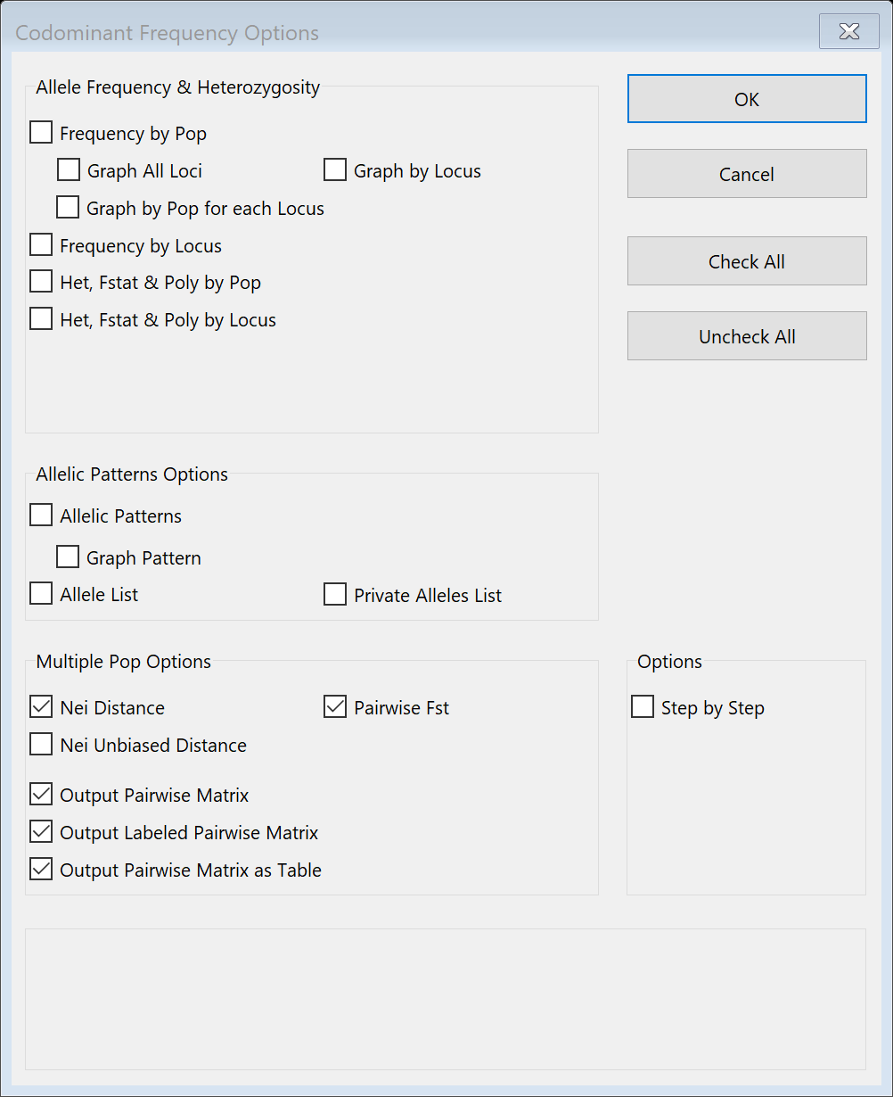
   6. **SELECT** “OK”
7. Pairwise Calculations of Shannon’s Indices
   1. **SELECT** “GenAlEx” from Ribbon
   2. **SELECT** “Frequency Based” button
   3. **SELECT** “Shannon” from GenAlEx drop down menu.
      1. **“**Pairwise Pops**”**
   4. Dialogue *Shannon Pairwise Pops Data parameter* 
      1. **SELECT** “Codominant” under two Columns/Locus
      2. 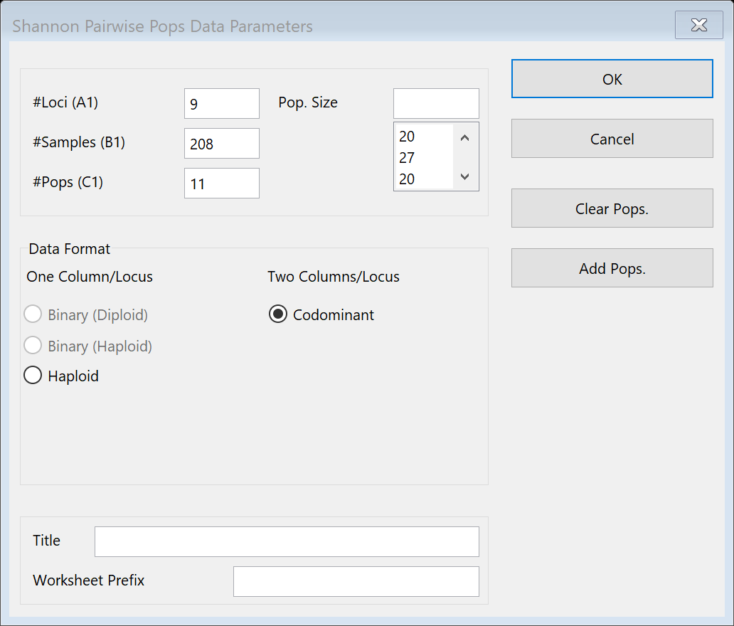
   5. **SELECT** “OK”
      1. 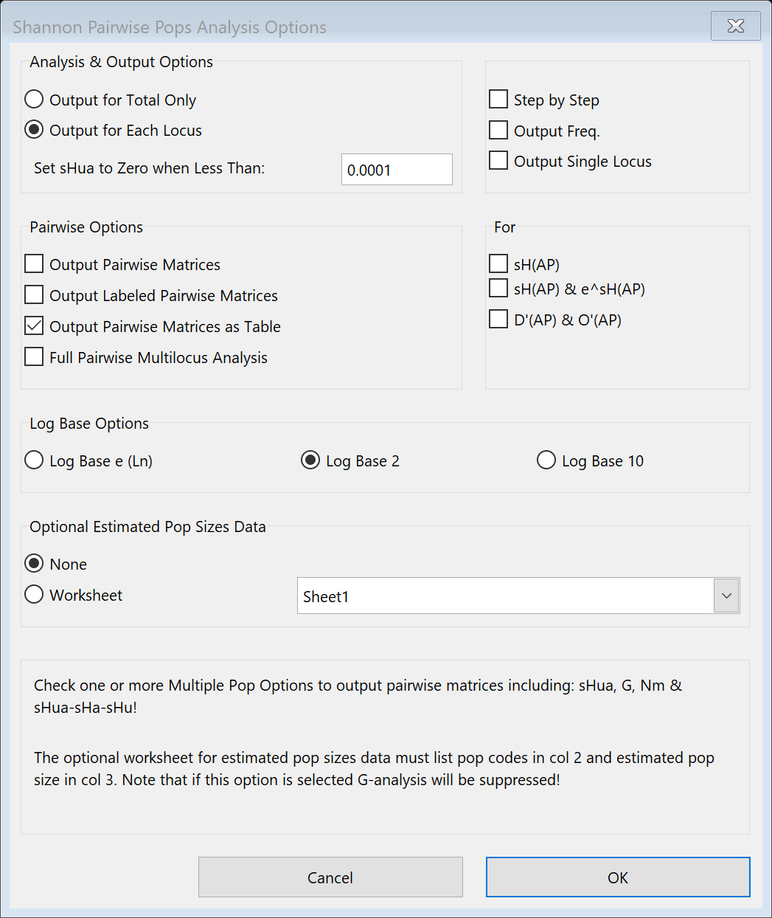
   6. **SELECT** “OK”
8. Principal Coordinate Analysis PCoA
   1. **SELECT** “NeiP” sheet in workbook
   2. **SELECT** “GenAlEx” button
   3. **SELECT** “Distance Based” button
   4. **SELECT** “PCoA” and move to Analysis
   5. Dialogue *PCoA Parameters*
   6. 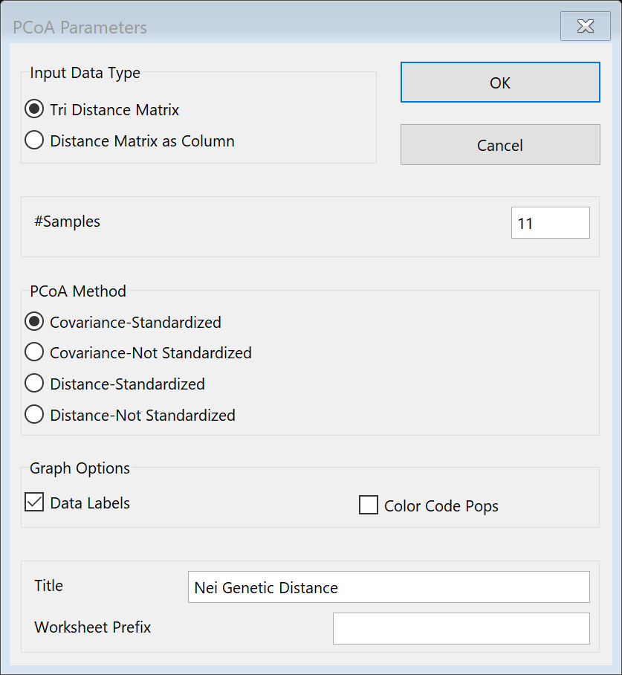
   7. **SELECT** “OK”
9. Hardy Weinberg Analysis
   1. **SELECT** “GenAlEx” from Ribbon
   2. **SELECT** “Disequil” button
   3. **SELECT** “HWE” button
   4. Dialogue *HWE Data Parameters*
      1. 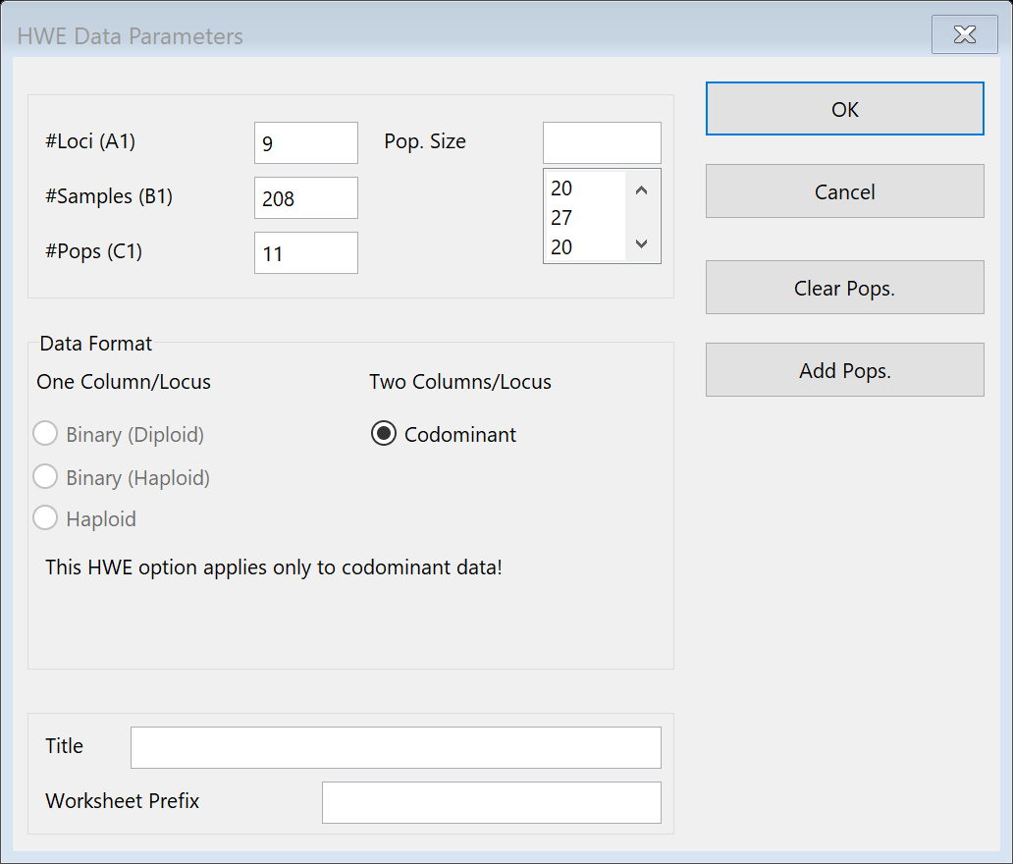
   5. **SELECT** “OK”
   6. **SELECT** “OK” When next dialogue appears
10. Calculating Haploid Distance
    1. **SELECT** “GenAlEx” from Ribbon
    2. **SELECT** “Distance Based” button
    3. **SELECT** “Genetic” from GenAlEx drop down menu.
    4. Dialogue *Genetic Distance Options* 
       1. **SELECT** “Haploid” under Distance Calculation
       2. **SELECT** “Output Total Distance Only” under Distance Output Options
       3. **SELECT** “To Worksheet” under Output
       4. **SELECT** “As Tri Matrix” under Output
       5. **SELECT** “Label Matrix” under Output
       6. **SELECT** “Pop” under Output
       7. **SELECT** “Labeled Opt” under Adv Output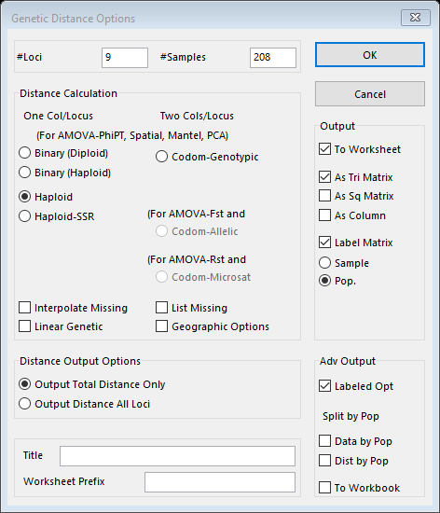
       8. **SELECT** “OK”
11. Calculating Codominant Genotypic Distance
    1. **SELECT** “GenAlEx” from Ribbon
    2. **SELECT** “Distance Based” button
    3. **SELECT** “Genetic” from GenAlEx drop down menu.
    4. Dialogue *Genetic Distance Options* 
       1. **SELECT** “Codom-Genotypic” under Distance Calculation
       2. **SELECT** “Output Total Distance Only” under Distance Output Options
       3. **SELECT** “To Worksheet” under Output
       4. **SELECT** “As Tri Matrix” under Output
       5. **SELECT** “Label Matrix” under Output
       6. **SELECT** “Sample” under Output
       7. 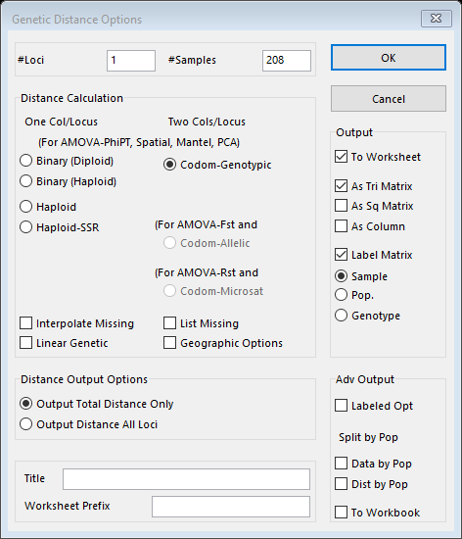
       8. **SELECT** “OK”
12. Calculating Binary Genetic Distance
    1. **SELECT** “GenAlEx” from Ribbon
    2. **SELECT** “Distance Based” button
    3. **SELECT** “Genetic” from GenAlEx drop down menu.
    4. Dialogue *Genetic Distance Options* 
       1. **SELECT** “Binary (Diploid)” under Distance Calculation
       2. **SELECT** “Output Total Distance Only” under Distance Output Options
       3. **SELECT** “To Worksheet” under Output
       4. **SELECT** “As Tri Matrix” under Output
       5. **SELECT** “Label Matrix” under Output
       6. **SELECT** “Sample” under Output
       7. 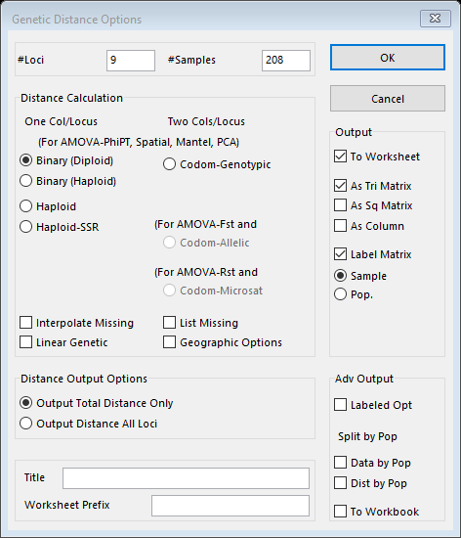
       8. **SELECT** “OK”
13. AMOVA
    1. **SELECT** “GenAlEx” from Ribbon
    2. **SELECT** “Distance Based” button
    3. **SELECT** “AMOVA” from GenAlEx drop down menu.
    4. Dialogue *Genetic Distance Options*
    5. **SELECT** “Raw Data”
    6. 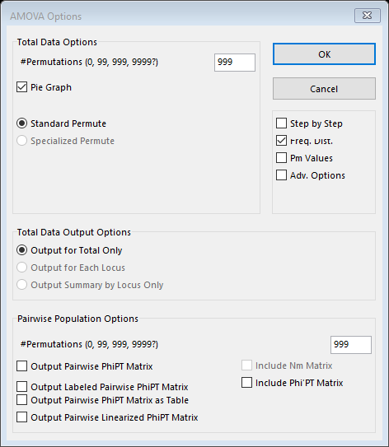
       1. **SELECT** “OK”
14. More PCoA
    1. **SELECT** sheet “PhiPTP”
    2. **SELECT** “GenAlEx” button
    3. **SELECT** “Distance Based” button
    4. **SELECT** “PCoA” and move to Analysis
    5. Dialogue *PCoA Parameters*
    6. 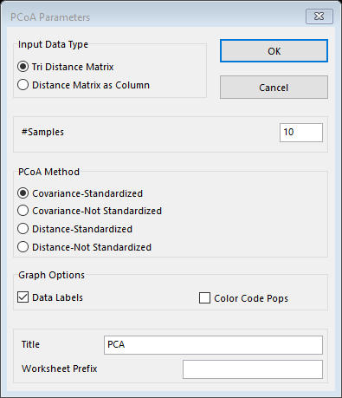
    7. **SELECT** “OK”
15. Mantel Tests for Isolation-by-Distance
    1. **SELECT** “GenAlEx” from Ribbon
    2. **SELECT** “Distance Based” button
    3. **SELECT** “Geographic Distance Options” from GenAlEx drop down menu.
    4. Dialogue *Geographic Distance Options*
    5. 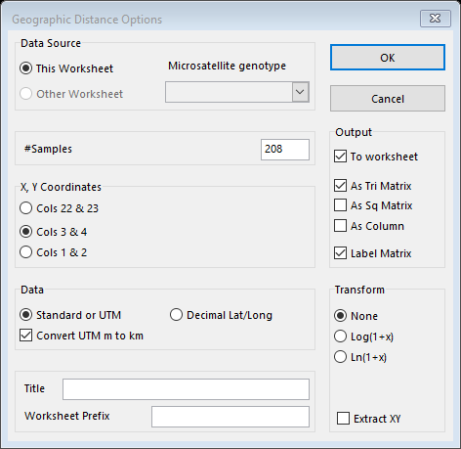
    6. **SELECT** “OK”
    7. **SELECT** sheet“GGD” to become x matrix
    8. **SELECT** “Distance Based” button
    9. **SELECT** “Mantel” button
    10. **SELECT** “Paired” button
    11. Dialogue *Mantel Parameters*
    12. 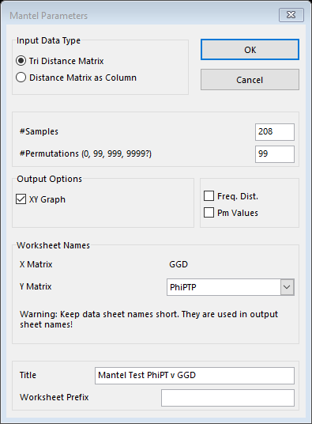
    13. **SELECT** “OK”
16. Statistical Testing for Mantel
    1. **SELECT** “PhiPTP” sheet
    2. **SELECT** “Color Rand” button
    3. **SELECT** “Rand Data” button
    4. **SELECT** “Shuffle Tri” button
    5. **SELECT** “GGD” sheet
    6. **SELECT** “Distance-Based” button
    7. **SELECT** “Mantel” button
    8. **SELECT** “Paired” button
    9. Dialogue *Mantel Parameters*
       1. 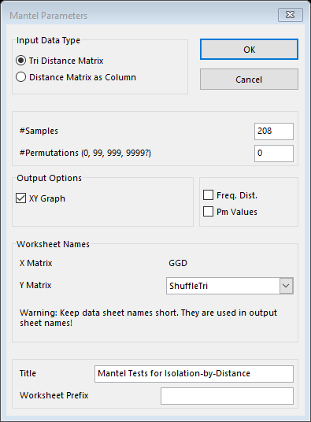
    10. **SELECT** “OK”
    11. Repeat to calculate an average.
17. Global Spatial Autocorrelation
    1. **SELECT** sheet“GGD”
    2. **SELECT** “GenAlEx” from Ribbon
    3. **SELECT** “Distance Based” button
    4. **SELECT** “Geographic Distance Options” from GenAlEx drop down menu.
    5. Dialogue *Geographic Distance Options*
       1. 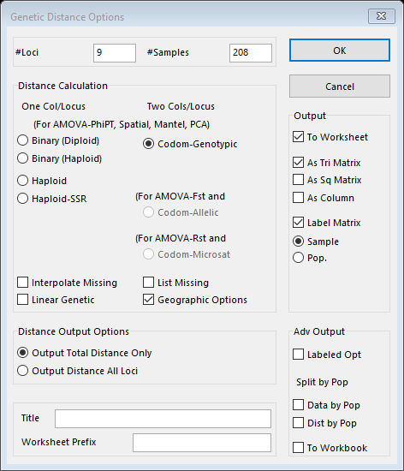
    6. **SELECT** “OK”
    7. Dialogue *Geographic Distance Options*
       1. 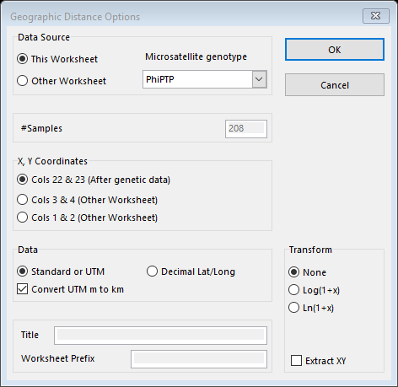
    8. **SELECT** “OK”